ASSIGNMENT -3

OBJECT STORAGE AND WATSON ASSISTANT IN IBM CLOUD

|  |  |
| --- | --- |
| Assignment Date | 19 October 2022 |
| Student Name | Kanimozhi K |
| Student Roll Number | 953519104004 |

Question-1:

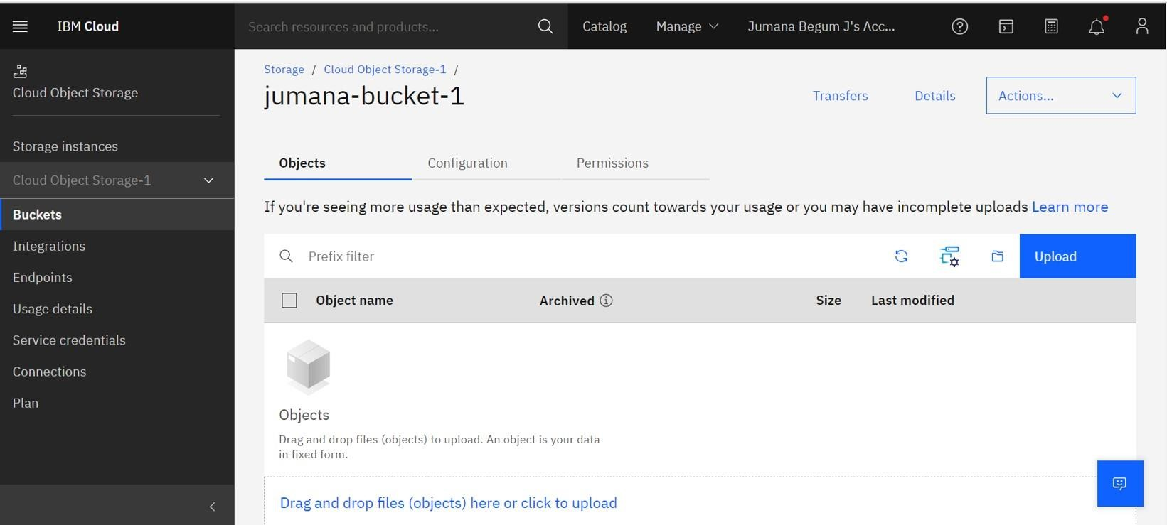Create a Bucket in IBM object storage.

Question-2:

Upload 5 images to ibm object storage and make it public. Write html code to display all the 5 images.

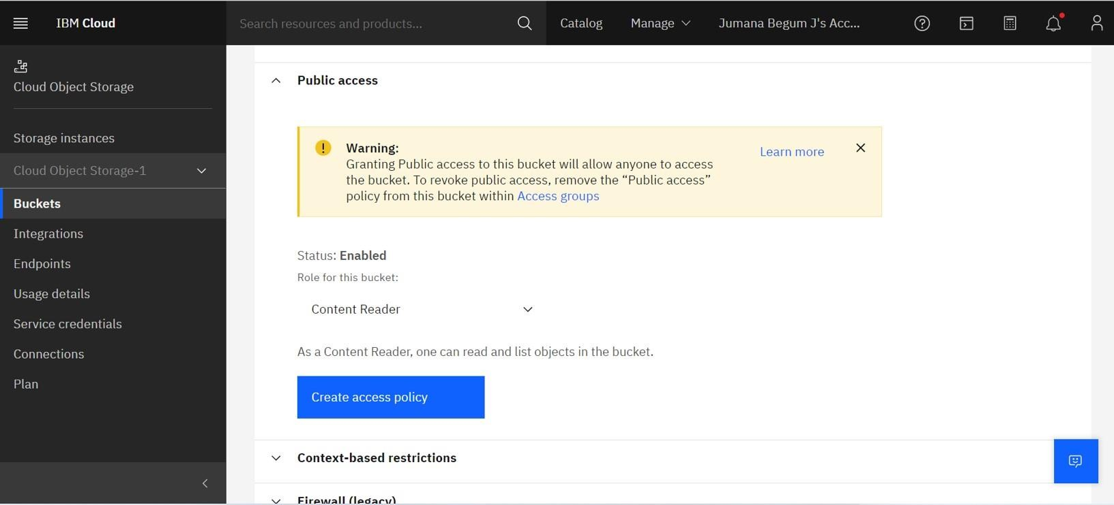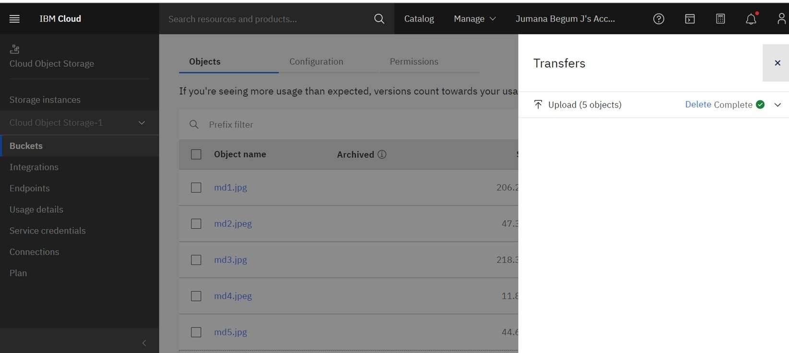

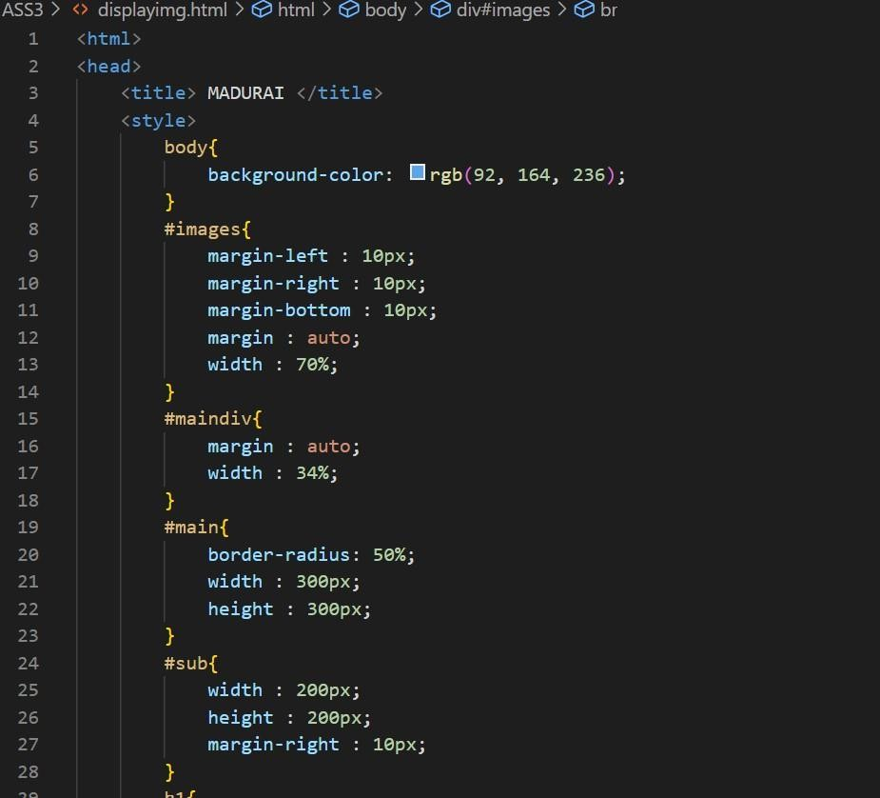HTML Code:

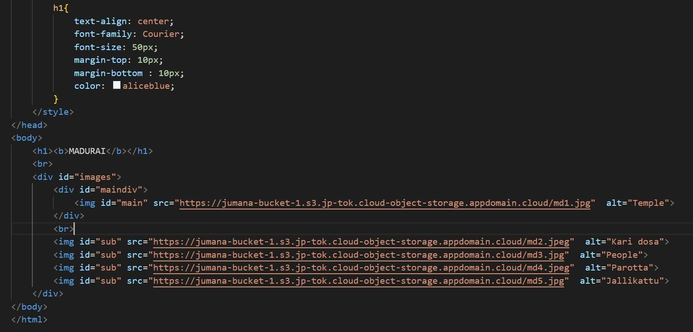

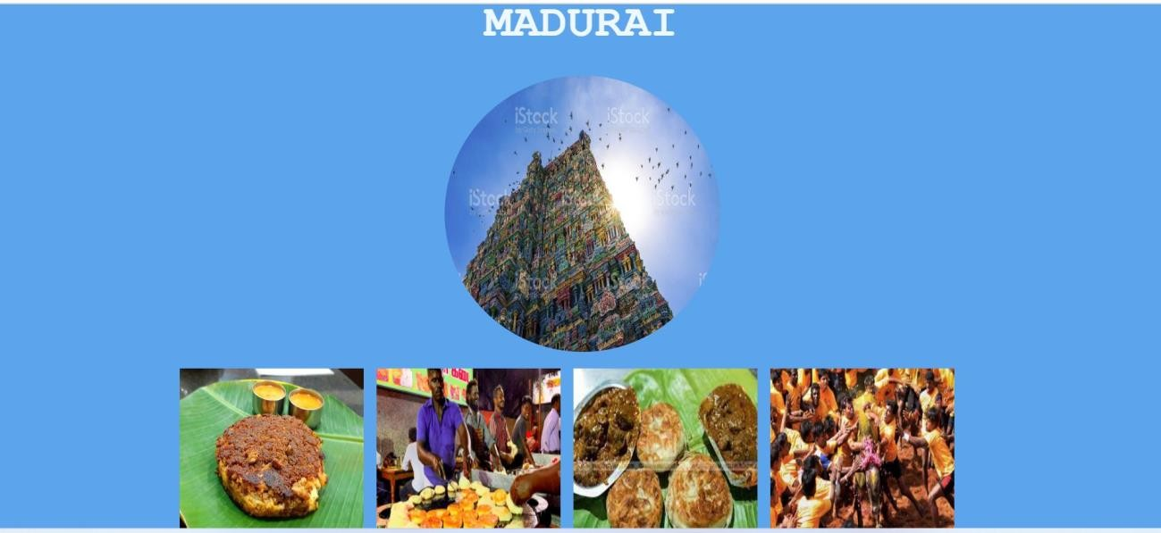Webpage:

Question-3:

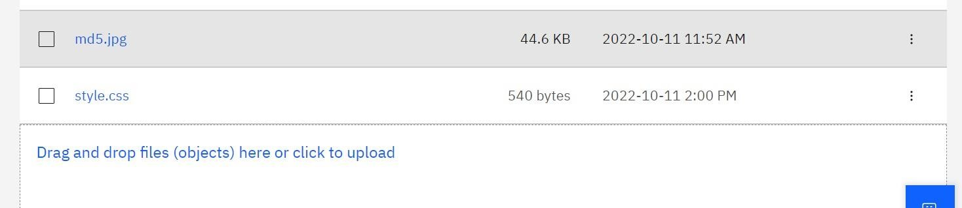Upload a css page to the object storage and use the same page in your HTML code Uploaded the styles.css file

URL of the uploaded styles.css file https://jumana-bucket-1.s3.jp-tok.cloud-object- storage.appdomain.cloud/style.css HTML Code:

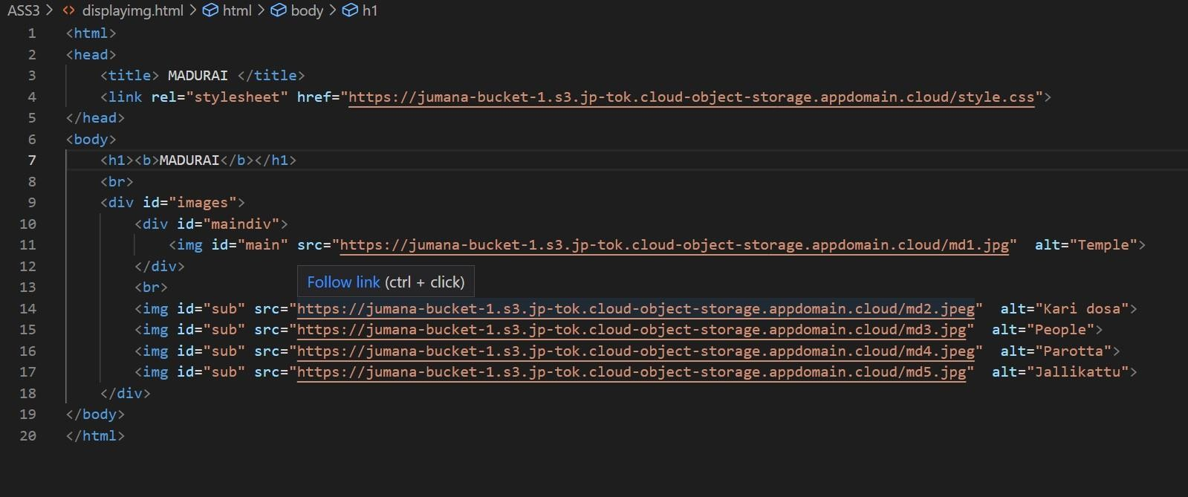

Webpage:

Question-4:

Design a chatbot using IBM Watson assistant for hospitals .

Ex: User comes with a query to know the branches for that hospital in your city. Submit the web URL of that chat bot as an assignment.

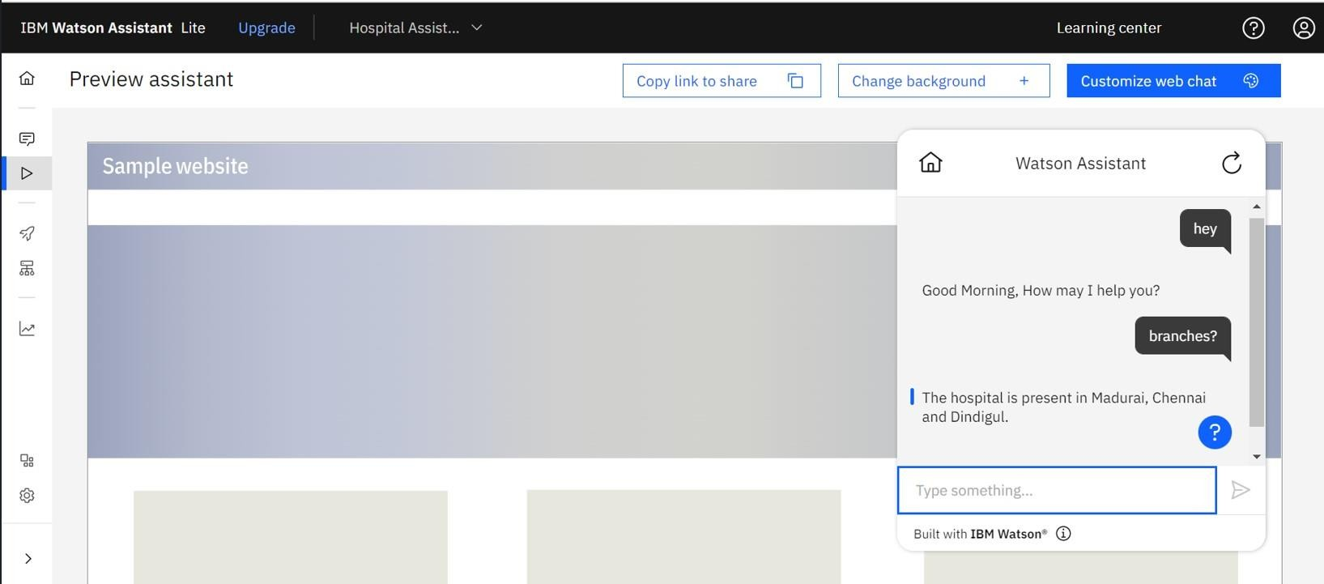

WEB URL of the chatbot:

[https://web-chat.global.assistant.watson.appdomain.cloud/preview.html?backgroundImageURL=https%3](https://web-chat.global.assistant.watson.appdomain.cloud/preview.html?backgroundImageURL=https%3A%2F%2Fus-south.assistant.watson.cloud.ibm.com%2Fpublic%2Fimages%2Fupx-511ac491-14cb-4157-a0b1-819b36502fbf%3A%3A66aa70c4-d167-47ed-9934-458d710d2bd4&integrationID=640d3a4f-2768-4e10-bb61-a41859be859d&region=us-south&serviceInstanceID=511ac491-14cb-4157-a0b1-819b36502fbf) [A%2F%2Fus-south.assistant.watson.cloud.ibm.com%2Fpublic%2Fimages%2Fupx-511ac491-14cb-](https://web-chat.global.assistant.watson.appdomain.cloud/preview.html?backgroundImageURL=https%3A%2F%2Fus-south.assistant.watson.cloud.ibm.com%2Fpublic%2Fimages%2Fupx-511ac491-14cb-4157-a0b1-819b36502fbf%3A%3A66aa70c4-d167-47ed-9934-458d710d2bd4&integrationID=640d3a4f-2768-4e10-bb61-a41859be859d&region=us-south&serviceInstanceID=511ac491-14cb-4157-a0b1-819b36502fbf) [4157a0b1-819b36502fbf%3A%3A66aa70c4-d167-47ed-9934-458d710d2bd4&integrationID=640d3a4f-](https://web-chat.global.assistant.watson.appdomain.cloud/preview.html?backgroundImageURL=https%3A%2F%2Fus-south.assistant.watson.cloud.ibm.com%2Fpublic%2Fimages%2Fupx-511ac491-14cb-4157-a0b1-819b36502fbf%3A%3A66aa70c4-d167-47ed-9934-458d710d2bd4&integrationID=640d3a4f-2768-4e10-bb61-a41859be859d&region=us-south&serviceInstanceID=511ac491-14cb-4157-a0b1-819b36502fbf) [27684e10-bb61-a41859be859d&region=us-south&serviceInstanceID=511ac491-14cb-4157-a0b1-](https://web-chat.global.assistant.watson.appdomain.cloud/preview.html?backgroundImageURL=https%3A%2F%2Fus-south.assistant.watson.cloud.ibm.com%2Fpublic%2Fimages%2Fupx-511ac491-14cb-4157-a0b1-819b36502fbf%3A%3A66aa70c4-d167-47ed-9934-458d710d2bd4&integrationID=640d3a4f-2768-4e10-bb61-a41859be859d&region=us-south&serviceInstanceID=511ac491-14cb-4157-a0b1-819b36502fbf) [819b36502f bf](https://web-chat.global.assistant.watson.appdomain.cloud/preview.html?backgroundImageURL=https%3A%2F%2Fus-south.assistant.watson.cloud.ibm.com%2Fpublic%2Fimages%2Fupx-511ac491-14cb-4157-a0b1-819b36502fbf%3A%3A66aa70c4-d167-47ed-9934-458d710d2bd4&integrationID=640d3a4f-2768-4e10-bb61-a41859be859d&region=us-south&serviceInstanceID=511ac491-14cb-4157-a0b1-819b36502fbf)

Question-5:

Create a Watson assistant service with 10 steps and use 3 conditions in it. Load that script in HTML page

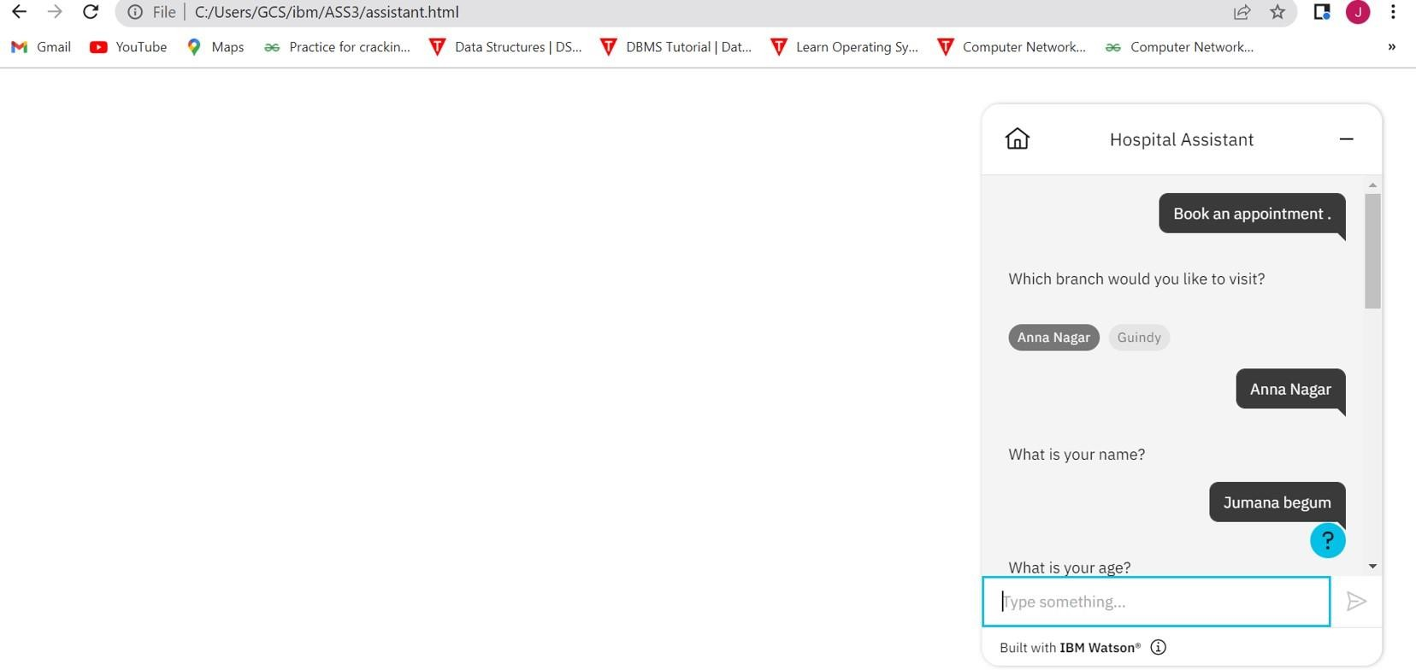

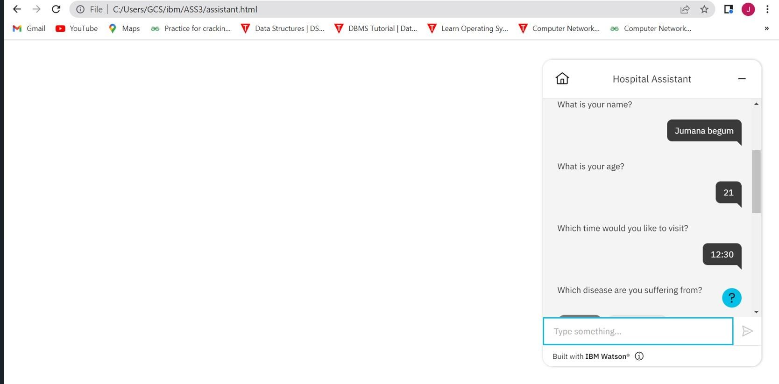

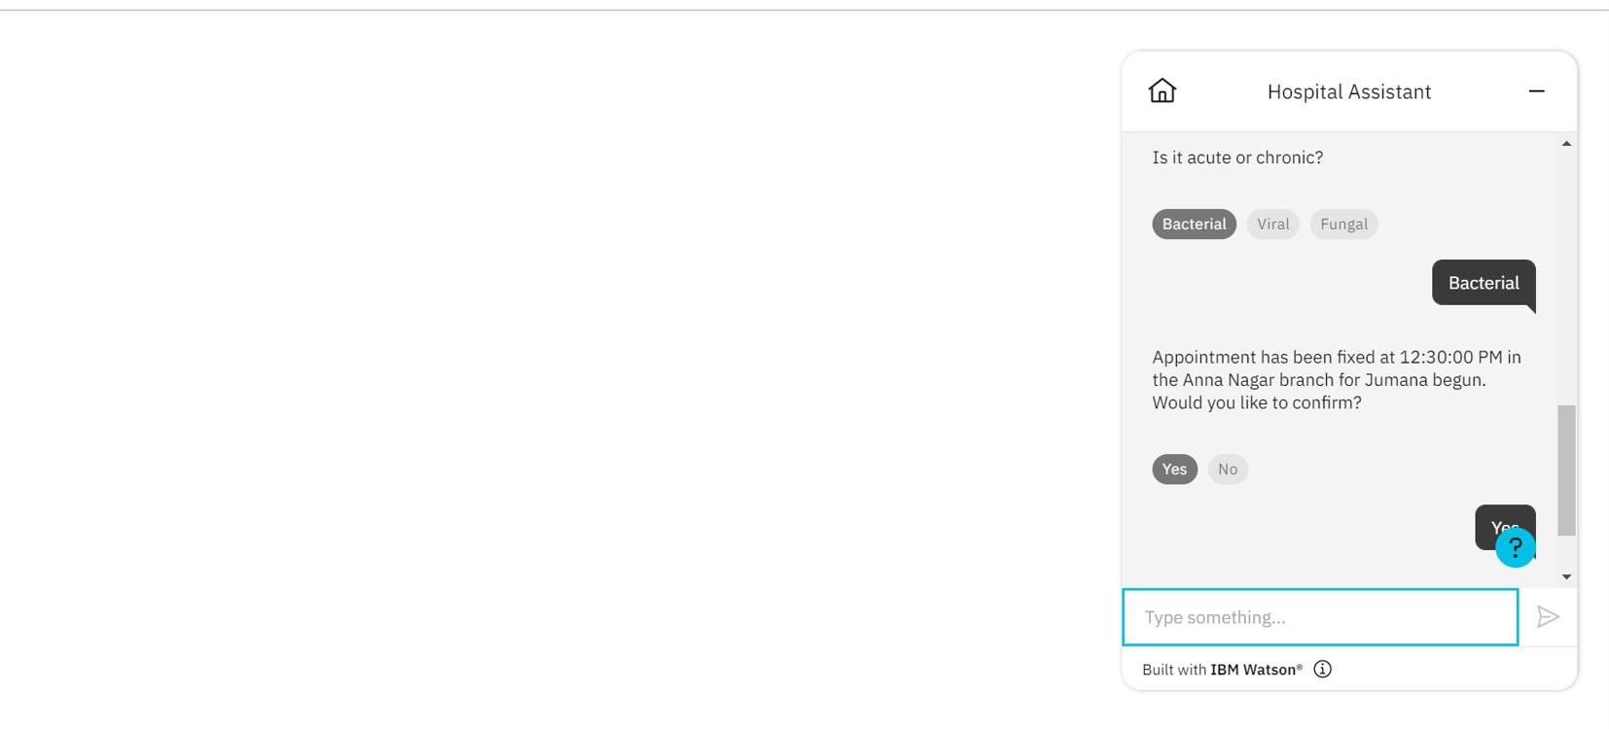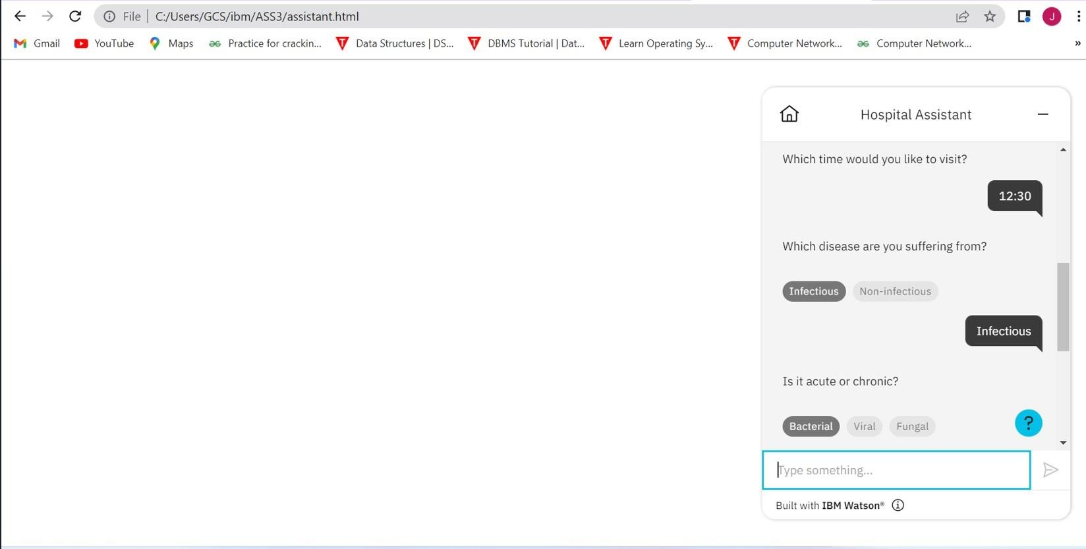

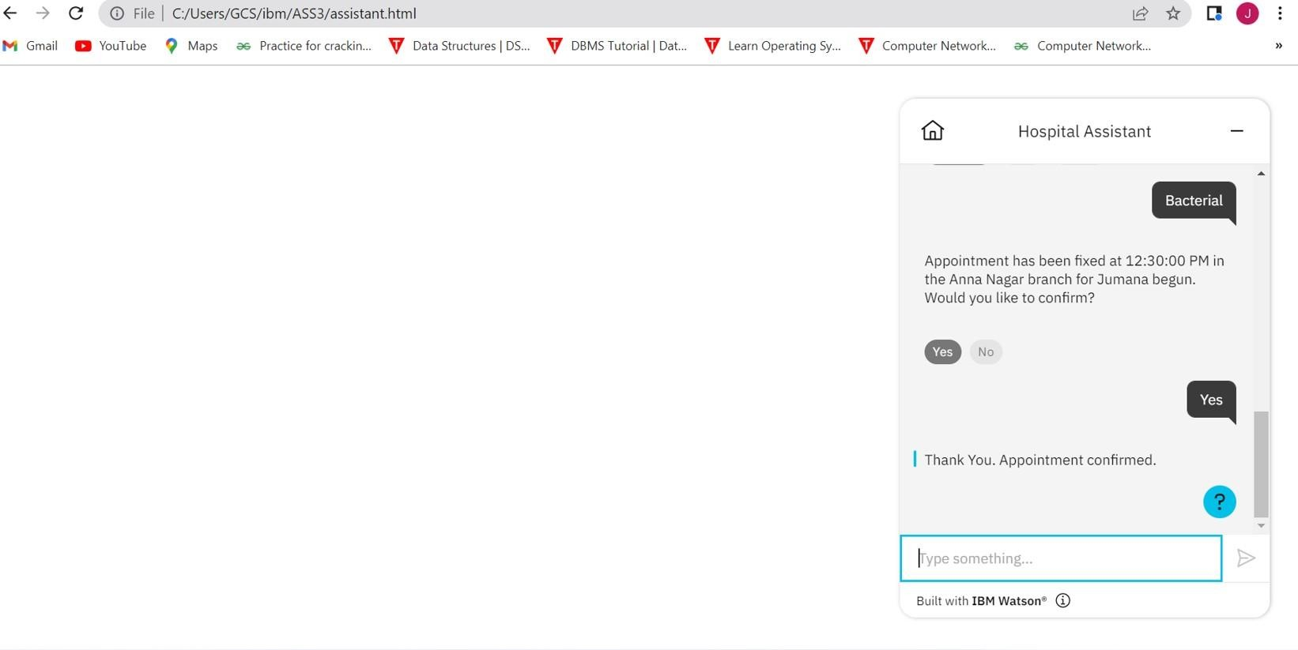

WEB URL:

https://web-chat.global.assistant.watson.appdomain.cloud/preview.html?backgroundImageURL=https%3 A%2F%2Fus-south.assistant.watson.cloud.ibm.com%2Fpublic%2Fimages%2Fupx-511ac491-14cb- 4157a0b1-819b36502fbf%3A%3A4b36f63b-de21-46fd-b875-c13253c68bf0&integrationID=ad461b6f- f5f9-40 2c-84c8-22efae03ac70&region=us-south&serviceInstanceID=511ac491-14cb-4157-a0b1- 819b36502fbf